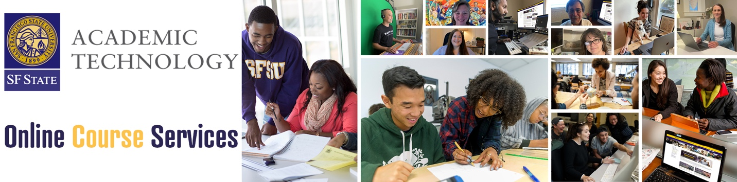

SF State’s Academic Technology unit support effective and quality online teaching through its Teaching and Learning with Technology team comprised of instructional designers and integrated with core learning technology support services across the unit.  This includes consultation, multi-modal training engagements, and coordination of CSU and curated external learning opportunities.  The team also collaborates with faculty to produce support materials and engagements and involves itself in campus governance to iteratively evolve its practice support campus needs.

**Team:**

* Andrew Roderick, Assistant Vice President, Academic Technology
* Angie Petty, Project Lead & Instructional Designer
* Breanna Hamm, Instructional Designer
* Brandon York, Instructional Designer

**Campus Partners:**

* The Center for Equity and Excellence in Teaching and Learning (CEETL)
* The Disability Programs and Resource Center (DPRC)
* Academic Technology Advisory Committee

## Section 1: SFSU OCS Accomplishments

### *2023-2024 OCS Goal 1:*

Continue to offer programming to faculty as Canvas becomes the new campus Learning Management System.

#### 2023-2024 OCS Goal 1 Accomplishments:

* Hired the first Canvas Faculty Fellow (English Department lecturer Esther Chan) who acted simultaneously as an internal consultant to the cross-disciplinary Canvas team, co-developed support materials for faculty, and participated in workshops and learning modules for faculty.
  + The faculty fellow joined weekly team members, infusing the faculty perspective into discussions on Canvas roll-out issues, outreach, and strategic planning. Additionally, the faculty fellow gained insight into the complex management of a Learning Management System at scale.
  + The faculty fellow co-developed workshops with Instructional Designers and attended (mostly) weekly online workshops to help and support to faculty in chat.
  + The faculty fellow provided direct support to faculty, holding online office hours and taking on one-on-one support engagements scheduled through Academic Technology.
  + The faculty fellow participated in strategic planning sessions that led to new programming (see “One Little Thing” below).
* Conceived and launched a new approach to faculty training and support with “One Little Thing”, a new short video series on Canvas and related topics focused on quick take-aways faculty can apply to their Canvas courses. The goal is to “meet faculty where they are” and as part of flagging longer length workshop attendance, provide quick, single-task oriented micro-resources that can improve course effectiveness.
  + <https://at.sfsu.edu/one-little-thing>
* Developed and launched the “Renovate and Elevate Your Canvas Courses” asynchronous training course focused on supporting faculty who have recently migrated to Canvas utilize best practices for streamlining course content and improving usage of Canvas features.
  + The course utilizes badging to help create a professional development incentive.
  + The course was launched for Spring 2024 and has 35 faculty enrolled (with a significant outreach to faculty for summer 2024 professional development).
  + <https://at.sfsu.edu/news/renovate-and-elevate-your-canvas-course>
* Developed and launched a full rebuild of the former Online Teaching Lab (OTL) course, now called “Excellence in Online Pedagogy (EOP)”. The module launched on April 1, 2024, for an initial 200 faculty who will receive stipends upon completion by May 6th, 2024.

### 2023-2024 OCS Goal 2:

SQuAIR research on CSU Fully Online with analysis on outgoing and incoming SF State student participation, course characteristics, and performance.

#### 2023-2024 Goal 2 Accomplishments:

Dr. Jackson Wilson, the SF State SQuAIR representative has been responsible for completing this goal. Following submission of 2023-2024 report, a campus discussion led to the broadening of the research topic from a focus on bichronous learning to a broader examination of online course modalities that contribute to campus courses being listed on CSU Fully Online. The study examines student success factors in CSU Fully Online courses offered from SF State analyzing data from Fall 2021 through Spring 2023 to develop observations regarding incoming, outgoing, and general performance of SF State students using the program. It additionally examines course characteristics and distribution across subject areas.

A full draft of the report will be in final draft as of April 2024. The draft is currently under review and discussion by a group of campus stakeholders and Wilson is continuing to conduct research and data analysis. We expect a completed report and presentation by end of Spring 2024.

## 

## Section 2: SFSU OCS Project Plan

### 2023-2024 Goal 1:

Focus programming and faculty development offerings on support for emerging changes to course delivery, modality, and flexible needs as academic departments and faculty explore adjustments based on university downsizing related to enrollment decline. Our programming will stress key principles (meeting faculty where they are, embedding QM/QLT rubric elements, and maintaining quality amidst faculty course revision).

Activities included:

* Embedding Faculty Voice and Practice into new and existing professional development materials: Our unit have developed a wide range of support documents, modules, and video support segment but has lacked faculty peer-based voices and demonstration in the materials. To fill this gap, we will be soliciting faculty with proven practice methods in online teaching to help co-develop materials or directly provide content that can be infused into new and existing professional development materials.
* Micro-modules focused on key pedagogical best practices: Develop new “micro-modules” on pedagogical topics related to the use of technology in teaching, transformation of course design, or incorporation of new modalities. These will integrate with the core “Excellence in Online Pedagogy” module or serve as stand-alone professional development options. Topics may include “Teaching in the Age of AI”, “Alternative Assessment Strategies”, “Understanding Academic Integrity”, “Accessibility with focus on Invisible Disabilities”, “Affordability in the Digital Age”, or various Canvas oriented skills. Badging will be provided upon completion.
* Expand Short Video-based Professional Development: Expand production of “One Little Thing” (<https://at.sfsu.edu/one-little-thing>) programming. Begin inclusion of faculty developed videos to show peer-based practices and expand repertoire of topics. These short segment videos (under 5 minutes) will also be embedded in modules and referenced as part of instructional design consultations and support engagements.

### 2023-2024 Goal 2:

SQuAIR research on the veracity of Learning Mode Codes.

Learning modes for each course section need to be accurate and well-communicated so students can understand what type of learning they are committing to when registering for courses. Departments need to choose a learning mode and communicate learning mode expectations to faculty. The University needs to also be aware of accurate learning modes to best understand impact on student outcomes and for accurate distance education reporting. The CSU uses a set of learning codes which need to inclusive of types of learning modes but mutually exclusive to avoid overlap or redundancy. Unfortunately, there are problems with the current learning codes. First, the numbering system is not intuitive. The codes range from 01 to 11, but 07 and 08 are not used. Second, certain codes may include very different practices, for example LM03 could be fully online or partially in-person. Moreover, the codes do not capture HyFlex learning (i.e., where a single class session is offered with more than one learning mode).

This study will use a survey to gather data about learning mode from a selection of faculty and compares that information to the learning mode code assigned to course section. The survey will query faculty on contact hours, student learning options, in-person contact hours versus require contact hours, and a range of other questions. The questions will be devised to detect issues of alignment to learning mode in comparison the actual instruction conducted so analysis can reveal key issues and point to remedies which can be shared at the University and system-wide level.